* **ipv6/nd/set 0 ra-interval=15-50**

Se realizará un Router Advertisement cada 15-50 segundos

* **ipv6/address/add interface=ether2 address=2001:db8:1::/64 eui-64=yes advertise=yes**

El prefijo 64 no es la máxima cantidad para aplicar en la red, pero, si queremos usar advertise solo podemos usar /64

* **ipv6/address/add interface=ether3 address=2001:db8:3::/48 eui-64=yes**

Con el prefijo /48 no podremos usar el advertise, pero si funcionara

**Configuración de dos Routers a Switch y Nuc:**

* ipv6/address/add interface=ether2 address=2001:db8:1234:f001::/64 eui-64=yes advertise=yes
* ipv6/route/add dst-address=2001:db8::1/64 gateway=fe80::eab:8eff:fefd:

**Configuración de dos routers entre ellos:**

* ipv6/address/add interface=ether1 eui-64=no advertise=no address=20 01:db8:ffff::1/64
* ipv6/route/add dst-address=2001:db8:2::/64 gateway=2001:db8:ffff::2

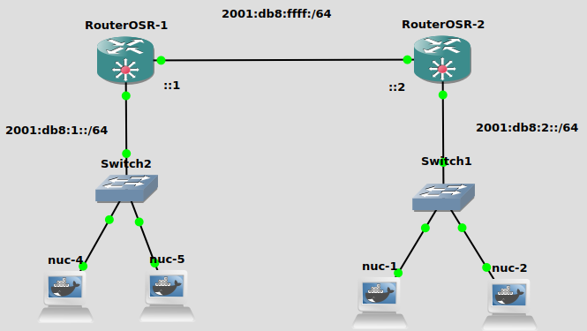

*COMANDOS PARA ROUTER PRINCIPAL:*

* ipv6/pool/add name=pool-movistar-15 prefix=2a02:9015::/32 prefix-length=42
* ipv6/dhcp-server/add interface=ether2 address-pool=pool-movistar-15 name=dhcp-e2

*COMANDOS PARA CLIENTES:*

* ipv6/dhcp-client/add interface=ether1 request=prefix pool-name=pool-cliente1 pool-prefix-length=64 add-default-route=yes
* ipv6/address/add interface=ether2 advertise=yes eui-64=yes from-pool=pool-cliente1
* ipv6/dhcp-server/add interface=ether2 address-pool=pool-cliente3 name=dhcp-e2

**EJERCICIO PASO A PASO POR COMANDOS:**

*IPv6: 2001:db8:xxxx::/48 → 2001:db8:a:f000::/52*

**COMANDOS PARA ROUTERS DE BORDE DE ÁREA:**

* ipv6/pool/add name=pool_ra prefix=2001:db8:a:f000::/52 prefix-length=56
* ipv6/dhcp-server/add address-pool=pool_ra interface=ether2 name=dhcp_e2
* ipv6/dhcp-server/add address-pool=pool_ra interface=ether3 name=dhcp_e3
* ipv6/address/add interface=ether2 address=2001:db8:a::aa1:1/126 eui-64=no advertise=no
* ipv6/address/add interface=ether3 address=2001:db8:a::aa2:1/126 eui-64=no advertise=no
* interface/bridge/add name=loopback
* ip address/add address=10.255.255.1 interface=loopback
* routing/id/add name=id_ospf select-dynamic-id=only-loopback
* routing/ospf/instance/add version=3 name=ospf3 router-id=id_ospf
* routing/ospf/area/add instance=ospf3 name=backbone
* routing/ospf/area/add instance=ospf3 name=A area-id=0.0.0.1 type=stub no-summaries default-cost=1
* routing/ospf/area/range/add area=A prefix=2001:db8:a::/48
* routing/ospf/interface-template/add area=backbone interfaces=ether1 type=ptp
* routing/ospf/interface-template/add area=A interfaces=ether2 type=ptp
* routing/ospf/interface-template/add area=A interfaces=ether3 type=ptp

**COMANDOS PARA ROUTERS INTRA - ÁREA**

* ipv6/dhcp-client/add interface=ether1 add-default-route=yes pool-name=pool_ra1 request=prefix pool-prefix-length=64
* ipv6/address/add interface=ether2 from-pool=pool_ra1 eui-64=yes advertise=yes
* ipv6/address/add interface=ether3 from-pool=pool_ra1 eui-64=yes advertise=yes
* interface/bridge/add name=loopback
* ip address/add address=10.255.255.11 interface=loopback
* routing/id/add name=id_ospf select-dynamic-id=only-loopback
* routing/ospf/instance/add version=3 name=ospf3
* routing/ospf/area/add instance=ospf3 name=A area-id=0.0.0.1 type=stub
* routing/ospf/interface-template/add area=A interfaces=ether2 passive
* routing/ospf/interface-template/add area=A interfaces=ether3 passive
* routing/ospf/interface-template/add area=A interfaces=ether1 type=ptp

